With 2nd row fixed in last column of second table – “NOT” was missing 😊

**From:** COWAN, Melanie   
**Sent:** Tuesday, 19 September 2023 7:36 pm  
**To:** [lucas.malla@lshtm.ac.uk](mailto:lucas.malla@lshtm.ac.uk); lucas malla <[lucasmatking@yahoo.com](mailto:lucasmatking@yahoo.com)>  
**Subject:** correction for PA indicator  
**Importance:** High

Hi Lucas,

As I just texted, there is a mistake in the first PA indicator in the fact sheet.

Here are the 2 lines of the matrix we have now:

|  |  |  |  |  |
| --- | --- | --- | --- | --- |
| PA_B_DAYS7 | q65 | 'H' |  | PA_B_DAYS7: Percentage of students who were physically active for a total of at least 60 minutes per  day on all 7 days (during the 7 days before the survey) |
| PA_B_DAYSNONE | q65 | 'A' |  | PA_B_DAYSNONE: Percentage of students who were not physically active for a total of at least 60 minutes per day  (during the 7 days before the survey) |

The issue is with the second one above.  The indicator text means it should be reporting the % of students who DIDN’T answer H.

Thus, I propose we do the following:

|  |  |  |  |  |
| --- | --- | --- | --- | --- |
| PA_B_DAYS7 | q65 | 'H' |  | PA_B_DAYS7: Percentage of students who were physically active for a total of  at least 60 minutes per day on all 7 days (during the 7 days before the survey) |
| PA_B_DAYSNOT7 | q65 | c('A','B','C','D','E','F','G') |  | PA_B_DAYSNOT7: Percentage of students who were not physically active for a total  of at least 60 minutes per day (during the 7 days before the survey) |
| PA_B_DAYSNONE | q65 | 'A' |  | PA_B_DAYSNONE: Percentage of students who were not physically active for a total  of at least 60 minutes per day on any day (during the 7 days before the survey) |

**PA_B_DAYSNOT7** thus becomes the indicator on the fact sheet (the first indicator under physical activity).

I highlighted the text in blue as I have just moved it from DAYSNONE and put a new description for DAYSNONE that is now correct.  We can keep DAYSNONE in the long reports.

This needs correcting for all sites, I believe.  I’m so sorry we didn’t catch this earlier.  Could you please rerun Jaipur with this correction as well as St Catherine as priority?

Thank you so much,

Melanie

***Melanie Cowan*** *Technical Officer   
Surveillance, Monitoring and Reporting Unit  
Department of Noncommunicable Diseases   
World Health Organization   
20 Avenue Appia   
CH 1211 Geneva, Switzerland   
Tel:*[*+41 (0)22 791 1288*](tel:+41227911288)*E-mail:*[*cowanm@who.int*](mailto:cowanm@who.int)

Not sure if this impacts how the DB_B_ALLSSB* indicators are calculated?  I suppose they take from DB_B_SSB* and DB_B_SODA*, so if there’s a fix in the SSB one, it will correct the ALLSSB one?

**From:** COWAN, Melanie   
**Sent:** Tuesday, 19 September 2023 8:57 pm  
**To:** [lucas.malla@lshtm.ac.uk](mailto:lucas.malla@lshtm.ac.uk); lucas malla <[lucasmatking@yahoo.com](mailto:lucasmatking@yahoo.com)>  
**Subject:** ssb error

Sorry, Lucas, another issue stemming from the annotated doc.  Please see the corrections needed for the numerators of 3 DB_B_SSB indicators:

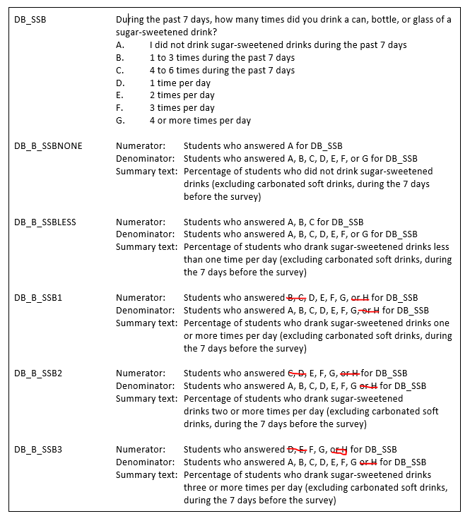

***Melanie Cowan*** *Technical Officer   
Surveillance, Monitoring and Reporting Unit  
Department of Noncommunicable Diseases   
World Health Organization   
20 Avenue Appia   
CH 1211 Geneva, Switzerland   
Tel:*[*+41 (0)22 791 1288*](tel:+41227911288)*E-mail:*[*cowanm@who.int*](mailto:cowanm@who.int)

Denominator reduction should be noted (excl ‘A’)

Image

***Melanie Cowan*** *Technical Officer   
Surveillance, Monitoring and Reporting Unit  
Department of Noncommunicable Diseases   
World Health Organization   
20 Avenue Appia   
CH 1211 Geneva, Switzerland   
Tel:*[*+41 (0)22 791 1288*](tel:+41227911288)*E-mail:*[*cowanm@who.int*](mailto:cowanm@who.int)

Denominator needs to be reduced (exclude A):



***Melanie Cowan*** *Technical Officer   
Surveillance, Monitoring and Reporting Unit  
Department of Noncommunicable Diseases   
World Health Organization   
20 Avenue Appia   
CH 1211 Geneva, Switzerland   
Tel:*[*+41 (0)22 791 1288*](tel:+41227911288)*E-mail:*[*cowanm@who.int*](mailto:cowanm@who.int)

Question text needs correcting in col F of matrix:

~~PA_SEDENTARY: How much time do you spend during a typical or usual day sitting or lying down doing such things as watching television, playing computer games, talking with friends, using your mobile phone, traveling in a motor vehicle, napping, or doing other activities sitting or lying down, such as playing board games, draft, or oware?~~

This is the correct text:

PA_SEDENTARY: How much time do you spend during a typical or usual day sitting or lying down doing such things as watching television, playing computer games, talking with friends, using your mobile phone, traveling in a motor vehicle, napping, or doing other activities sitting or lying down, such as talking on the phone?

~~DR_SCHDRUGGED:During the past 12 months, how many times did you attend school under influence of drugs, such as cannabis (also called marijuana and wee) or cocaine?~~

Corrected text:

DR_SCHDRUGGED: During the past 12 months, how many times did you attend school under the influence of drugs, such as marijuana (ganja) or cocaine?

***Melanie Cowan*** *Technical Officer   
Surveillance, Monitoring and Reporting Unit  
Department of Noncommunicable Diseases   
World Health Organization   
20 Avenue Appia   
CH 1211 Geneva, Switzerland   
Tel:*[*+41 (0)22 791 1288*](tel:+41227911288)*E-mail:*[*cowanm@who.int*](mailto:cowanm@who.int)